**Synology Folder Synchronisatie**

1. Make sure there is a **SRV_SCANS** user, if not create this user
2. Create Shared Folder via **Control Panel > Shared Folder > Create** (ex SCANS)

Give SRV_SCANS Read/Write access to this folder

1. Go to Filestation , click on newly created folder and go to **Tools >** **Mount Remote Folder** > **CIFS Shared Folder**

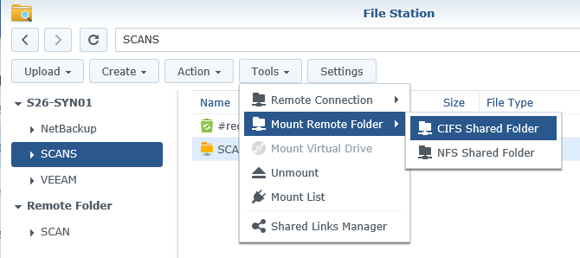

1. **Enter Folder name *(full path to scan folder on file server)* , account and password from user account who can access this folder on the fileserver.**

**Click Mount**

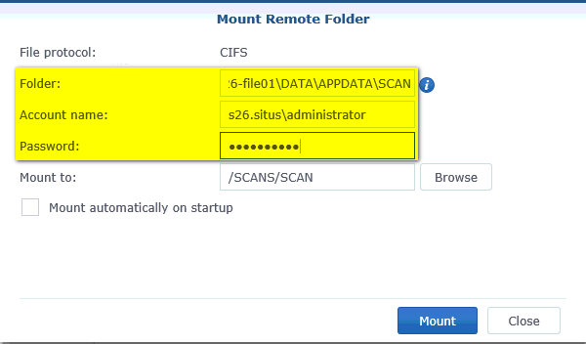

**Best to create a similar SRV_SCANS account in AD with same password and give this user Read/Write access to the network folder where scanned files needs to be stored.**

1. Setup printer to use scan folder on synology, use SRV_SCANS account and password.

